**NETWORKING & SYSTEM ADMINISTRATION LAB**

**Name: Nikhil Jais**

**Roll No: 25**

**Batch: B**

**Date: 04-04-2022**

**Experiment No.: 5**

# Aim

Familiarization of basic Linux commands.

# Procedure

1. **cp a.txt b.txt :** It copy the contents of 1st file to the 2nd file.

# Syntax : cp Src_file Dest_file Output :

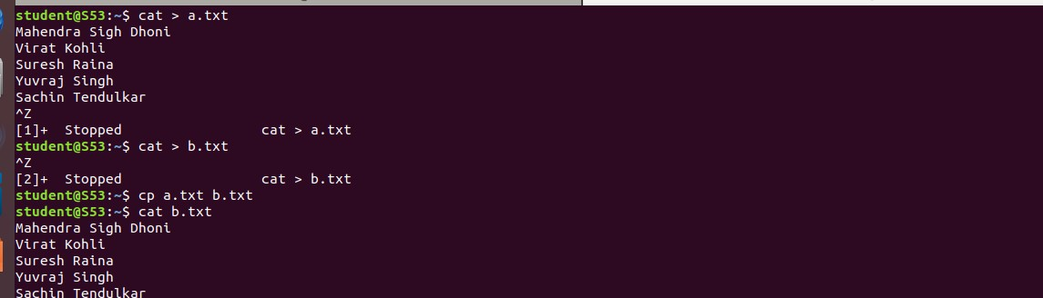

1. **cp -r Pictures vishnuvjk :** cp copies all files of the source directory to thedestination directory, creating any files or directories needed.

# Syntax : cp -r Src_directory Dest_directory

**Output :**



1. **cp -i h.txt a.txt :** With this option ,system first warns the user before overwriting the destination file. cp prompts for a response, if you press **y** then it overwrites the file and with any other option leave it uncopied.

# Syntax : $ cp -i a.txt b.txt

**cp: overwrite 'b.txt'? y**

# Output :



1. **mv b.txt pictures:** to move content in source file to destination file.

# Syntax : mv source destination

**Output :**



1. **mv -i a.txt c.txt :** This option makes the command ask the user for confirmation before moving a file that would overwrite an existing file, you have to press **y** for confirm moving, any other key leaves the file as it is.

# Syntax : mv -i source destination

**Output :**

